WT PRACTICAL FILE

SIMARJOT KAUR

BCA AIML

***GROUP 1***

***Q 1= Create a simple html tag using basic tags?***

<html>

<head>

<title>hello</title>

</head>

<body>

<h1>body of page</h1>

</body>

</html>

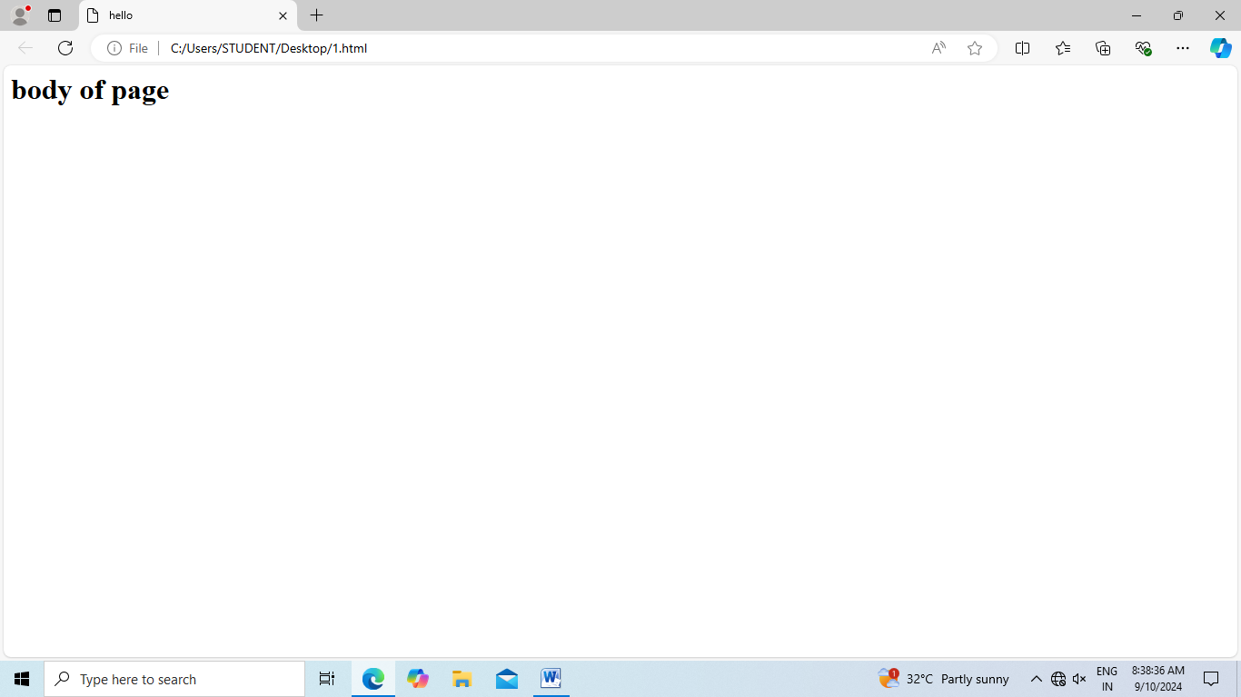

2create a web page that displays your name to the screen

<html>

<head>

<title>body of page </title>

</head>

<body>

<h1>"simar kaur "</h1>

</body>

</html>

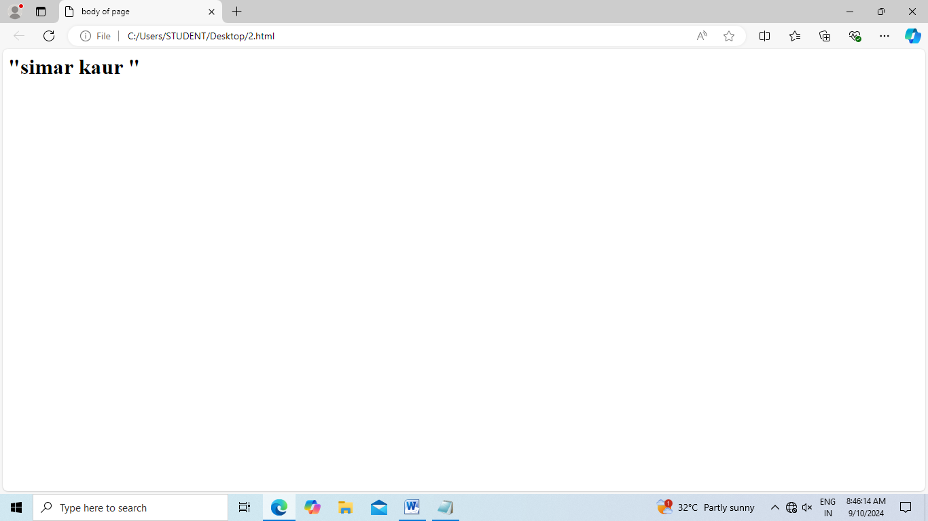

**3.**Q3. Create a web page and show the output from 1 to 10 in separate lines.

Input:

<html>

<head><title>My first page </title>

</head>

<body> 1<br>2<br>3<br>4<br>5<br>6<br>7<br>8<br>9<br>10</body>

</html>

Output: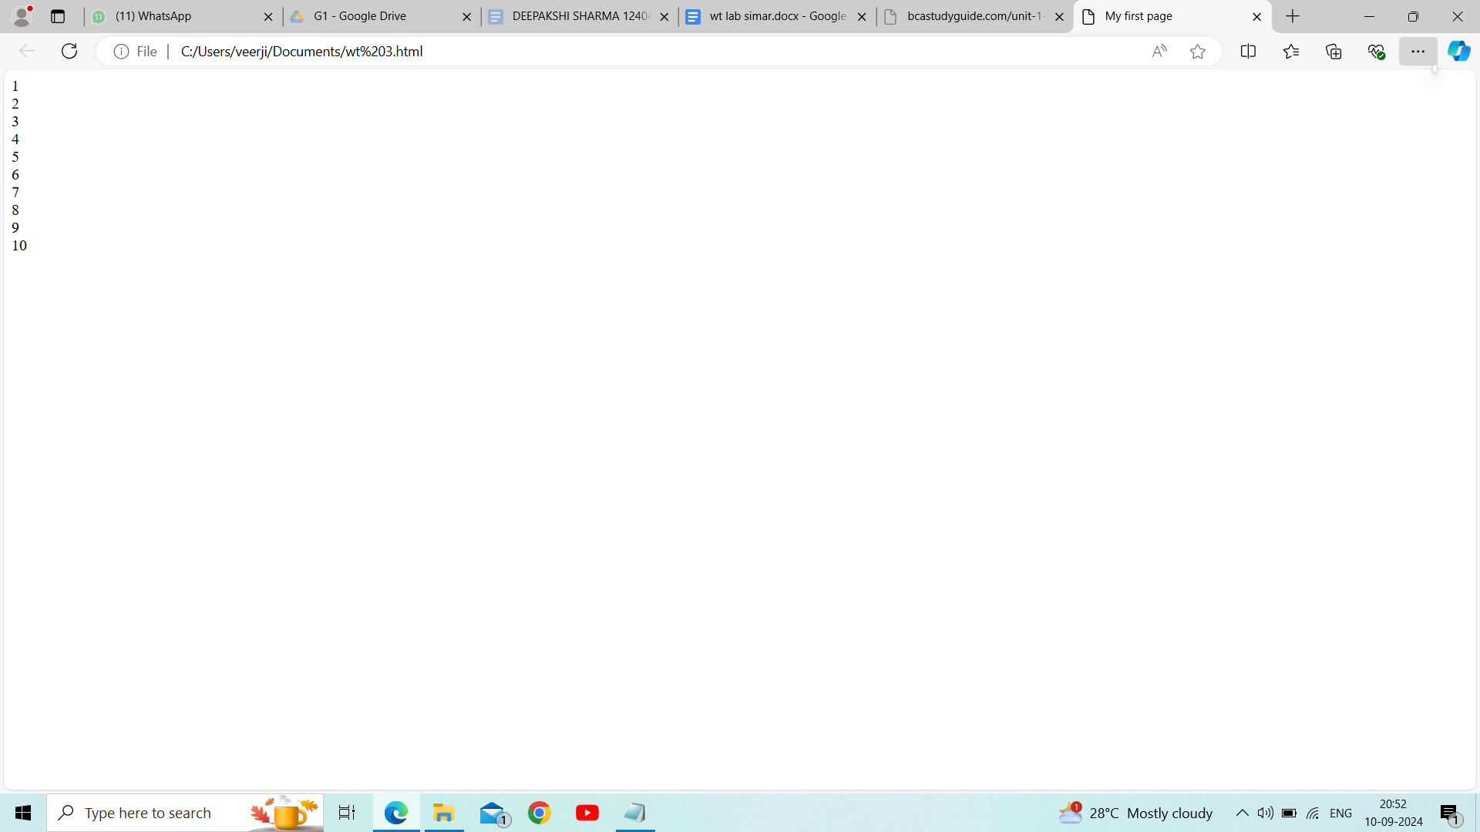

**4.**. Create a web page and show the output from 1 to 10 in separate lines, each number being in different color.

Input:

<html>

<head><title>My first page </title>

</head>

<body> 1<br><font color='red'>2<br><font color='green'>3<br><font color='blue'>4<br><font color='orange'>5<br><font color='pink'>6<br><font color='brown'>7<br><font color='yellow'>8<br><font color='cyan'>9<br><font color='purple'>10</body>

</html>

Output:

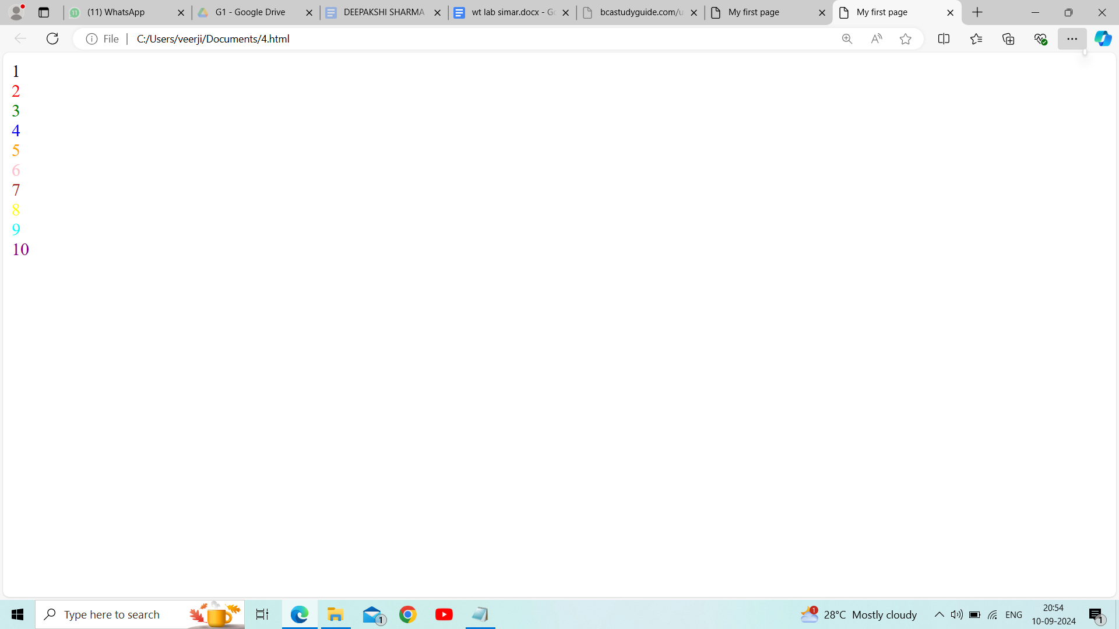

**5.** How do I make a picture as a background on my web pages?

Input:

.<html>

<head><title>My first page </title>

</head>

<body background="https://cdn.britannica.com/48/252748-050-C514EFDB/Virat-Kohli-India-celebrates-50th-century-Cricket-November-15-2023.jpg"> 1<br><font color='red'>2<br><font color='green'>3<br><font color='blue'>4<br><font color='orange'>5<br><font color='pink'>6<br><font color='brown'>7<br><font color='yellow'>8<br><font color='cyan'>9<br><font color='purple'>10</body>

</html>

6.Q6. Create a web page to print a paragraph with 4-5 sentences, each sentence shall have a different font.

Input:

<html>

<head><title>My first page </title>

</head>

<body><font face="arial">Cricket is a bat-and-ball game that is played between two teams of eleven players on a field,<br></font>

<font face="georgia">at the centre of which is a 22-yard (20-metre; 66-foot) pitch with a wicket at each end,<br></font>

<font face="impact">each comprising two bails balanced on three stumps.<br></font>

<font face="courier">Two players from the batting team (the striker and nonstriker) stand in front of either wicket holding bats,</font>

<font face="gill sans">with one player from the fielding team (the bowler) bowling the ball towards the striker's wicket from the opposite end of the pitch.</font>

</body>

</html>

Output:

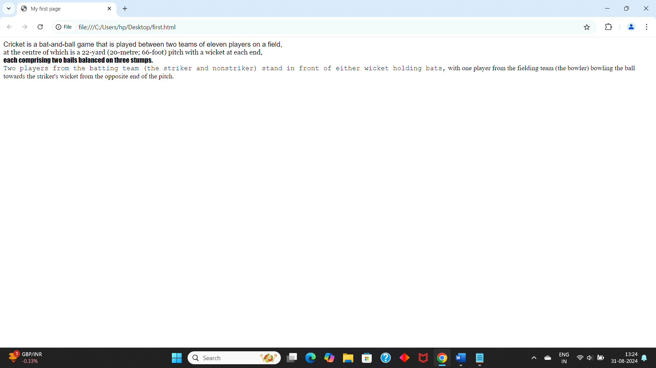

**Q6=Create a web page to print a paragraph with 4-5 sentences, each sentences shall have a different font?**

**<html>**

**<head>**

**<title> BCA IB </title>**

**</head>**

**<body>**

**<h1>simarjot kaur</h1><P>**

**<B>My name is simarjot kaur.</B><br>**

**<I>I am Currently studing in manav rachna international institute of research and science </I>**

**<br> <U> i am pursuing BCA(AI/ML) </U>.**

**<br><B> My Hobbies are dancing,reading books and cooking for my special one.</B><br>**

**</p>**

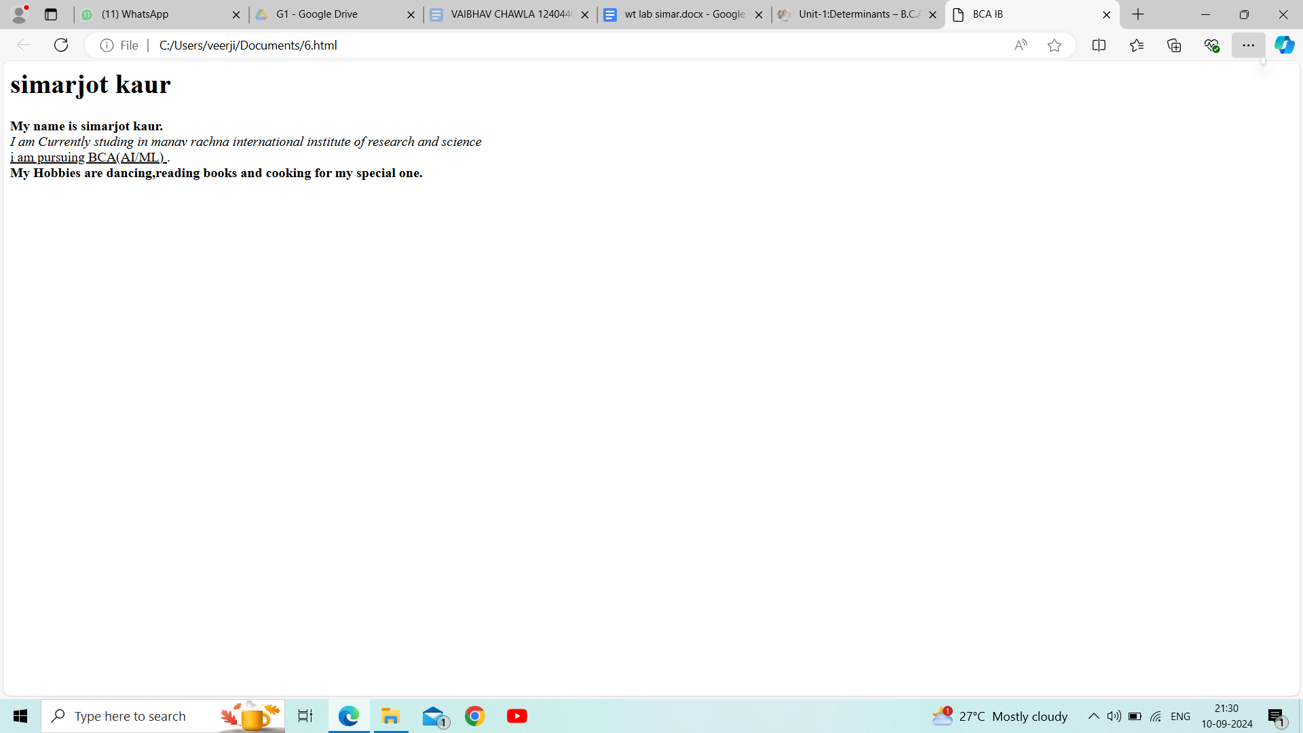

Q7. Write HTML code to print a paragraph that is description of a book, it shall include the title should be underlined and all adjectives shall be bold and italics.

Input:

<html>

<head><title>

Description

</title>

</head>

<body>

<center><h1>DRACULA</h1></center>

<br>

<h2><b><i>BRAM STOKER </i></b></h2>

<br>

Dracula is a gothic horror novel by Bram Stoker, published on 26 May 1897. An epistolary novel, the narrative is related through letters, diary entries, and newspaper articles. It has no single protagonist and opens with solicitor Jonathan Harker taking a business trip to stay at the castle of a Transylvanian nobleman, Count Dracula. Harker escapes the castle after discovering that Dracula is a vampire, and the Count moves to England and plagues the seaside town of Whitby.

- <u> DRACULA </u> WAS MY FAVOURITE CHARACTER AND <u> VAMPIRE </u> WAS <b> <u> AMAZING </b> </u>.

</body>

</html>

Output:

**Q8: Write HTML code to print your name using heading tag, every letter shall be of different heading size?**

**<HTML>**

**<HEAD>**

**<Title> simar </Title>**

**</HEAD>**

**<BODY>**

**<H1> A</h1>**

**<H2> B</h2>**

**<H3> C</h3>**

**<H4> D</h4><br>**

**<H5> E</h5>**

**<H6> F</h6>**

**<H1> G</h1>**

**<H2> H</h2>**

**</body>**

**</html>**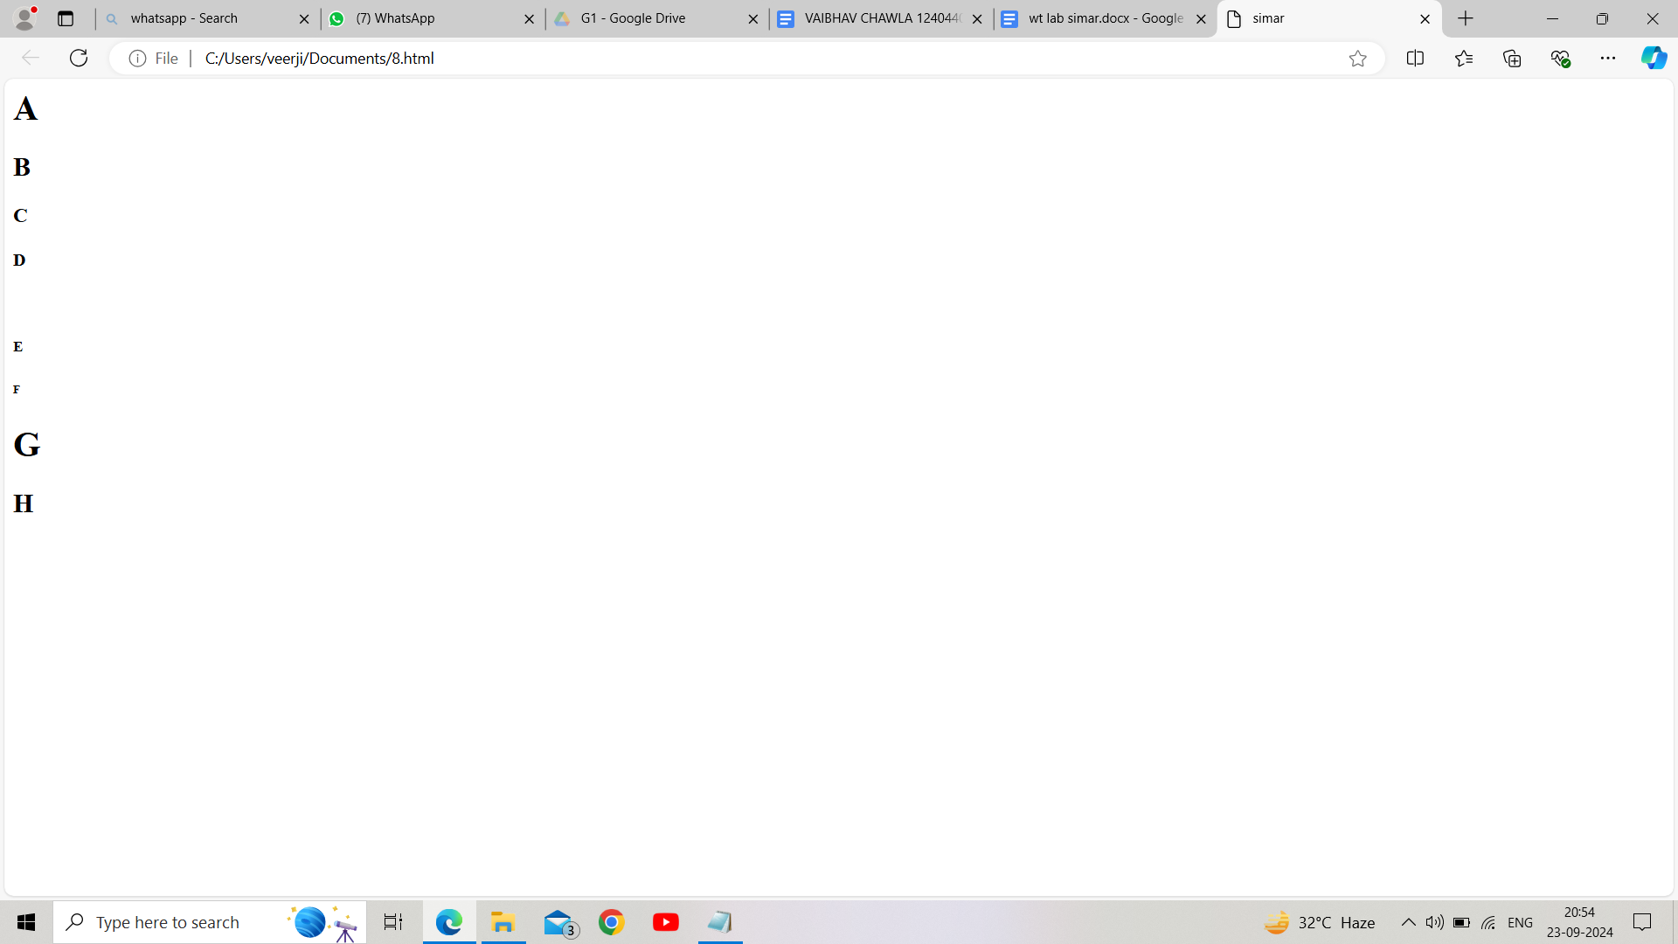

Q9. Write HTML code to print the sequence of numbers 1 – 20. Each number shall be in a different line

with number 2 next to it as subscript, an equal sign and the result.

Input:

<html>

<head>

<title> number sequence</title>

</head>

<body>

<p>1<sub>2</sub> = 2</p>

<p>2<sub>2</sub> = 4</p>

<p>3<sub>2</sub> = 6</p>

<p>4<sub>2</sub> = 8</p>

<p>5<sub>2</sub> = 10</p>

<p>6<sub>2</sub> = 12</p>

<p>7<sub>2</sub> =14</p>

<p>8<sub>2</sub> = 16</p>

<p>9<sub>2</sub> = 18</p>

<p>10<sub>2</sub> = 20</p>

<p>11<sub>2</sub> = 22</p>

<p>12<sub>2</sub> = 24</p>

<p>13<sub>2</sub> = 26</p>

<p>14<sub>2</sub> =28</p>

<p>15<sub>2</sub> = 30</p>

<p>16<sub>2</sub> = 32</p>

<p>17<sub>2</sub> = 34</p>

<p>18<sub>2</sub> = 36</p>

<title> number sequence</title>

</head>

</body>

</html>

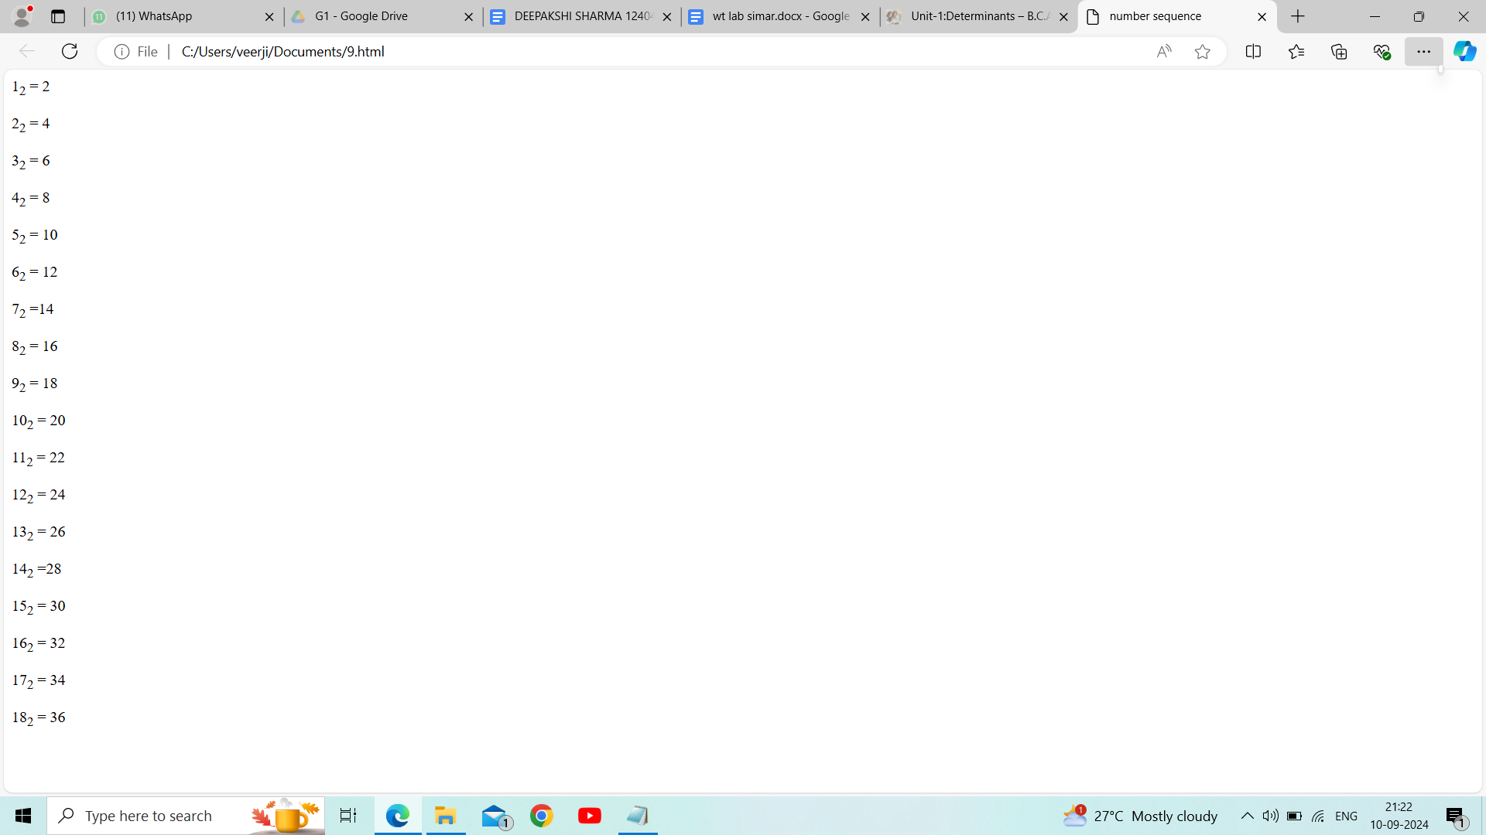

10.**Q10.** Write HTML code to display an image with border of size with width 200, height 200 pixel, leaving H space and V space of your choice with image hanging in the right side on the screen.

**Ans. <HTML>**

**<HEAD>**

**<TITLE>INTRODUCTION</TITLE>**

**<style>**

**img{**

**border:2px solid black;**

**width:400px;**

**height:500px;**

**display:block;**

**margin-left:auto;**

**margin-right:0;**

**margin-top:40px;**

**margin-bottom:50px;**

**</style>**

**</HEAD>**

**<BODY>**

**<img src="C:\Users\simar\Pictures\Screenshots/display.jpg"**

**alt="sample image">**

**</BODY>**

**</HTML>**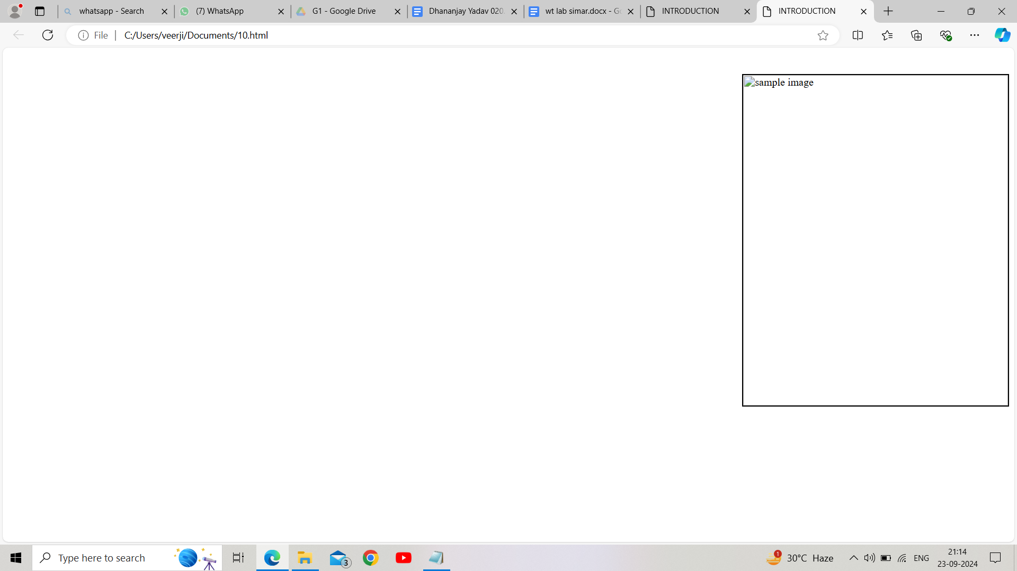

**Q11.** Write HTML code to create a web page with heading. The heading shall be displayed at the top-center of the page and the image shall be at the center, just below the heading.

**Ans. <HTML>**

**<HEAD>**

**<TITLE>INTRODUCTION</TITLE>**

**<style>**

**body{**

**margin:0;**

**font-family:arial, sans-serif;**

**text-align:center;**

**justify-content:center;**

**align-items:center;**

**</style>**

**</head>**

**<body>**

**<h1>diwali 2024</h1>**

**<img src="C:\Users\simarjot\OneDrive\Pictures/festival.jpg"**

**alt="FESTIVAL CELEBRATION">**

**</BODY>**

**</HTML>**

**OUTPUT –**

**Q12.** Write HTML code using Multimedia tags.

**Ans. <HTML>**

**<HEAD>**

**<TITLE>MULTIMEDIA TAGS</TITLE>**

**</head>**

**<body>**

**<h1 align="center">MULTIMEDIA</H1>**

**<hr>**

**<video src="C:\Users\simar\OneDrive\Pictures/moon.mp4" controls="controls" width="820" height="520">**

**</video>**

**<br>**

**<audio src="C:\Users\simar\OneDrive\Pictures/moon.mp3" controls="controls" autoplay="autoplay">**

**<embed src="name.pdf" width="px" height="px">**

**<object data="file.name" width="px" height="px">**

**</object>**

**</BODY>**

**</HTML>**

**OUTPUT –**

**13: Create a Table using Rowspan and Colspan taking example of**

**student Record?**

**Ans:**

**<html>**

**<head>**

**<title> my world </title>**

**</head>**

**<table>**

**<tr>**

**<th colspan="2">Name</th>**

**<th>Age</th>**

**</tr>**

**<tr>**

**<td>jack</td>**

**<td>Smith</td>**

**<td>26</td>**

**</tr>**

**<tr>**

**<td>Elvee</td>**

**<td>yourn</td>**

**<td>28</td>**

**</tr>**

**</table>**

</body>

</html>

# 

### 14.Write HTML code using table tag and cellpadding and cell spacing as its attributes.



### <html>

### <head></head>

### <body>

### <table border="2pt" cellspacing="5pt" cellpadding="5pt">

### <tr>

### <th>S.no</th>

### <th>Roll no.</th>

### <th>Name</th>

### <th>Address</th></tr>

### <tr>

### <td>1</td>

### <td>123</td>

### <td>ABC</td>

### <td>FBD</td></tr>

### <tr>

### <td>2</td>

### <td>456</td>

<td>xyz</td>

<td>gurgaon</td></tr>

<tr>

<td>3</td>

<td>789</td>

<td>pqr</td>

<td>palwal</td>

</table>

</body>

</html>

### 

Q15. Create unordered, ordered and definition Lists taking example of your subjects in MCA IST, IInd and IIIrd Semester. Input :

Input :

<html>

<head></head>

<body>

<h3> Subjects in BCA sem 1</h3>

<ol>

<li>Web technologies</li>

<ul>

<li>introduction to Networks</li>

<li>introduction to e-mail</li>

<li>introduction to html</li>

</ul>

<li>Introduction to IT & programming in C</li>

<ul>

<li>Input output devices</li>

<li>compilers,Interpreters,assemblers</li>

<li>various programs in c </li>

</ul>

<li>mathematics</li>

<ul>

<li>matrices</li>

<li>surds and insurdes</li>

</body>

</html>

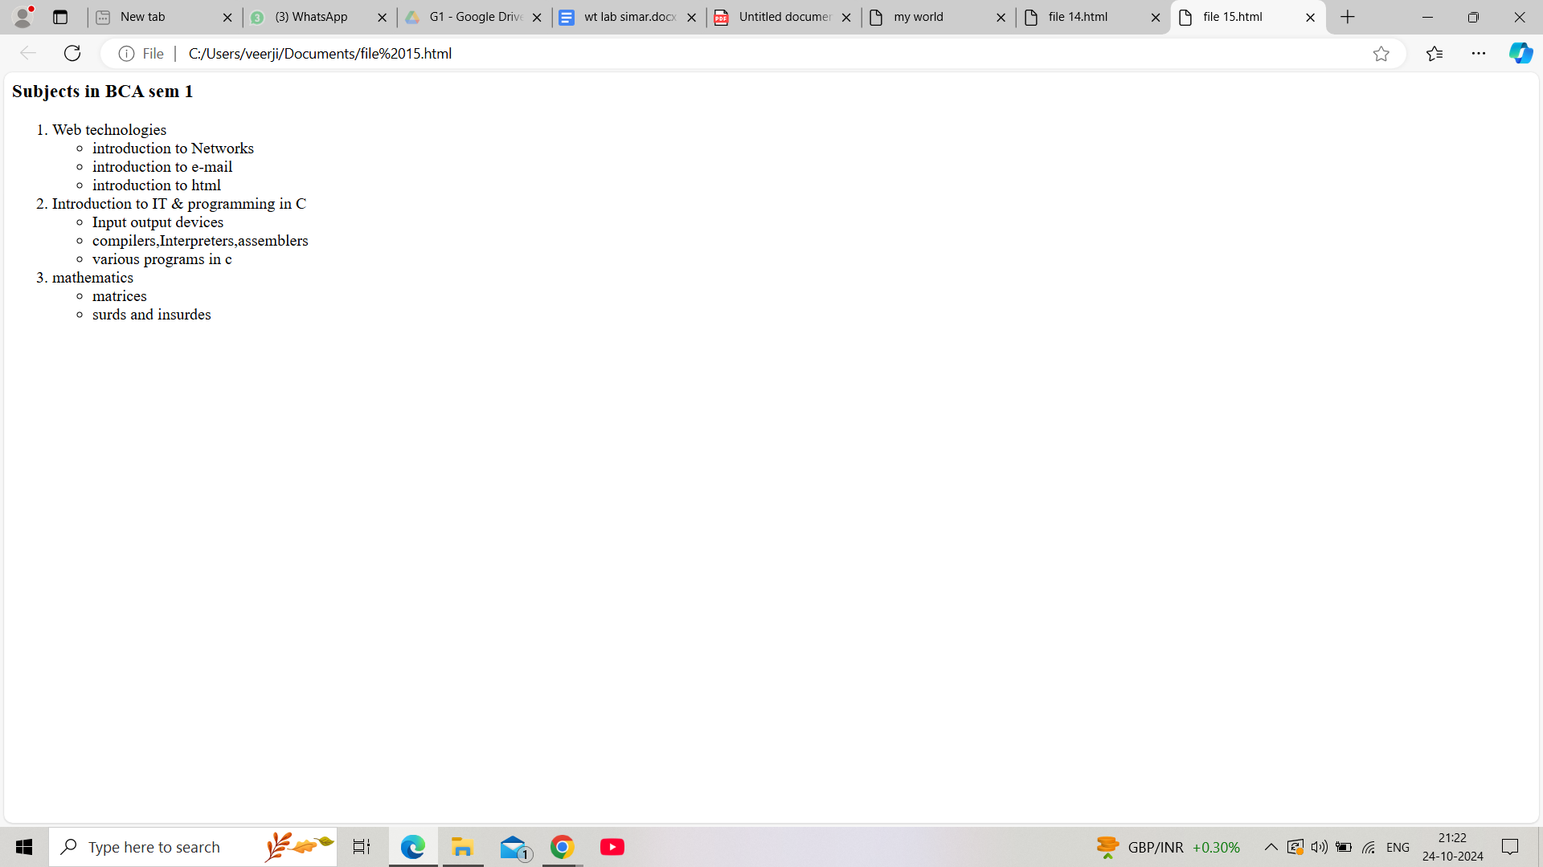

16.Write HTML code using<frame set> and <frame>tag with all its attributes .

<**html**>

<**head**>

<**title**>frameset attribute</**title**>

</**head**>

<**body**>

<**frameset** cols="30%, 40%, 30%">

<**frame** name="top" src="attr1.png" />

<**frame** name="main" src="gradient3.png" />

<**html**>

<**head**>

<**title**>frameset attribute</**title**>

</**head**>

<**body**>

<**frameset** cols="30%, 40%, 30%">

<**frame** name="top" src="attr1.png" />

<**frame** name="main" src="gradient3.png" />

<**frame** name="bottom" src="col_last.png" />

<**noframes**>

<**body**>The browser you are working does

not support frames.</**body**>

</**noframes**>

</**frameset**>

</**body**>

</**html**>

Q17Write HTML code to design a form in HTML using controls and buttons such as Teaxtbox, Textarea, password, submit button, browse button, drop-down menu?

<html>

<head>

<title> Form </title>

<head>

<body>

<h2>form</h2>

<form>

<fieldset>

<legend><font color=”red”size =”5” face =”arial”><b>COLLEGE

FORM</b></font></legend>

<label for =”fname” id=name><b>name:</label></br>

<input type=”text” required/>

<label for="fname" id=name><b>Name:</label><br>

<input type="text" required/>

<label for="12th Marks" id="name"><b> 12th Marks(%):</b></label>

<input type="number" max="100" min="33" required/>

<b> Upload here</b>

<input type="file"/><br>

<label for="Email" id=name required>Email:</label><br>

<input type="Email"/>

<label for="10th Marks" id="name" required ><b>10th

Marks(%):</b></label>

<input type="number" max="100" min="33"/>

<b> Upload here</b>

<input type="file" name="mark sheet"/><br>

<label for="Name" id=name>Father's Name:</label><br>

<input type="text"/>

<font color="red">Charactor certificate</font>

<input type="file" required/><br>

<label for="Course Name" id=name>Course Name:</label><br

<input type="text"/>

<font color="red">Migration certificate</font>

<input type="file"/><br><br>

<b>Phone No:</b>

<input type="text" size="9" maxlength="10" required/>

<hr>

<b><font size="2" color="red" face="arial"><u>

gender</u></font></b><br>

<input type="radio" name="gender"/>

<label for="gender" name="gender">Male</label>

<input type="radio" name="gender"/>

<label for="gender" name="gender">female</label>

<input type =”radio” name=”gender”/>

<label for=”gender” name =”gender”>others </label><br>

<b><font size="2" color="red" face="arial"

><u>Subject</u></font></b><br>

<input type="Checkbox"/>

<label for="Subject" name="subject">Wt</label>

<input type="Checkbox"/>

<label for="Subject" name="subject">Dbms</label>

<input type="Checkbox"/>

<label for="Subject" name="subject">ITPC</label>

<input type="Checkbox"/>

<label for="Subject" name="subject">Eng</label>

<input type="Checkbox"/>

<label for="Subject" name="subject">History</label><br>

<font color="red" size="2" face="arial"><u>Section</u></font>

<select id="section" name="section" required>

<option value="A">A</option>

<option value="B" selected>B</option>

<option value="C">C</option>

<option value="D">D</option>

</select>

<hr>

<lable for="date" name="birth">DOB:</lable>

<input type="date" max="2007" min="2003" required/><br><br>

<lable for “date” name=”birth”>date of joining </table>

<input type =”month’ id = “joining” required/><br>

<br>

<input type = “image” height =”90” width =”400” align =”right”

<button >submit</button>

<button> cancel<button>

</fieldset>

</form>

</body>

</html>

OUTPUT:

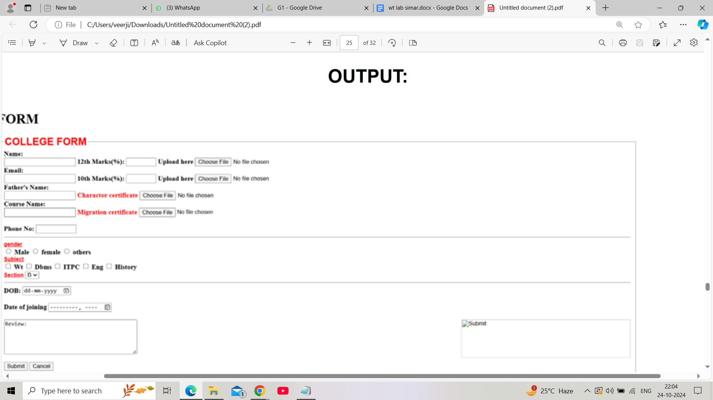

Q18. Write HTML code to design a Registration Form in HTML. Input:

Input:

<!DOCTYPE html>

<html>

<head>

<title>Grade Volleyball Registration Form</title>

</head>

<body>

<h1>Grade Volleyball Registration Form</h1>

<form action="submit.php" method="post">

<label for="first_name">Participant Name</label><br>

<input type="text" id="first_name" name="first_name"

placeholder="First"><br>

<input type="text" name="last_name"

placeholder="Last"><br><br>

<label for="age">Age</label><br>

<input type="number" id="age" name="age"><br><br

<label for="grade">Grade</label><br>

<select id="grade" name="grade">

<option value="">Please select</option>

<option value="1">1</option>

<option value="2">2</option>

</select><br><br>

<label for="school_district">School District</label><br>

<input type="text" id="school_district"

name="school_district"><br><br>

<label for="shirt_size">Shirt Size</label><br>

<select id="shirt_size" name="shirt_size">

<option value="">Please select</option>

<option value="s">Small</option>

<option value="m">Medium</option>

<option value="l">Large</option>

<option value="xl">Extra Large</option>

</select><br><br>

<label for="parent_first_name">Parent Name</label><br>

<input type="text" id="parent_first_name"

name="parent_first_name" placeholder="First"><br>

<input type="text" name="parent_last_name"

placeholder="Last"><br><br>

<label for="emergency_contact">Emergency Contact </label><br>

<input type="text" id="emergency_contact"

name="emergency_contact"><br><br>

<inpuytype="submit" value="Submit">

</form>

</body>

</html>

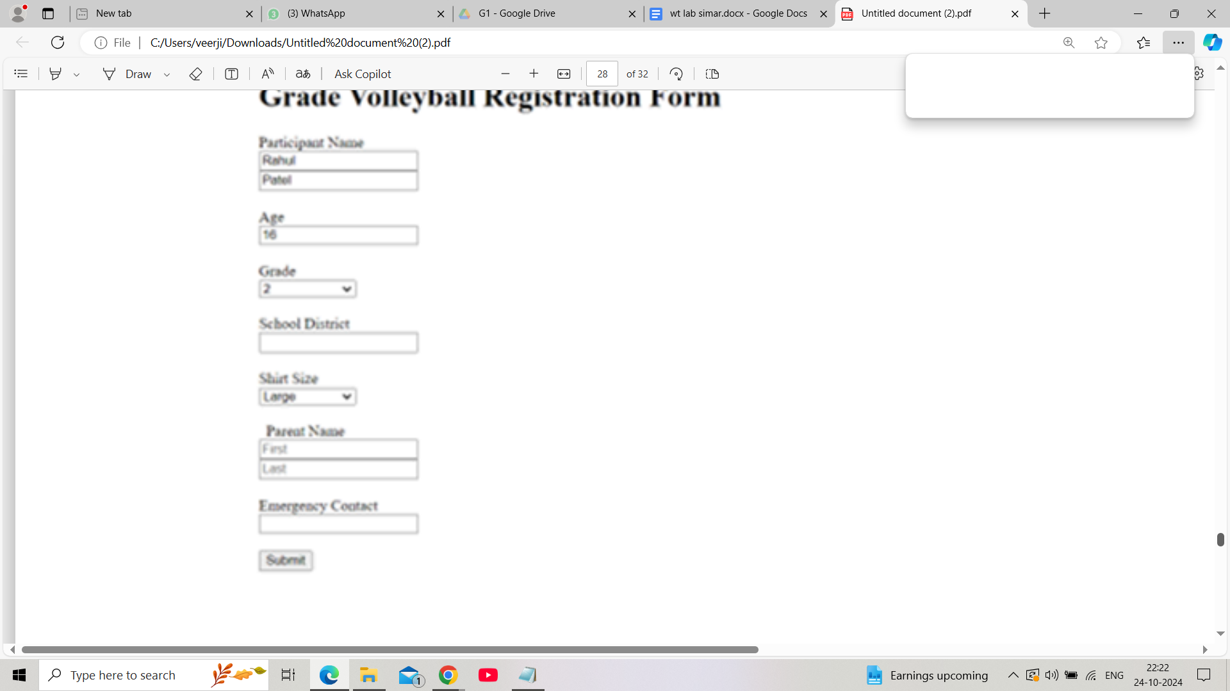

Q19. Write HTML code to design a student admission Form in HTML.

Input:

<!DOCTYPE html>

<html>

<head>

<title>Student Admission Form</title>

</head>

<body>

<h1>Student Admission Form</h1>

<form action="submit.php" method="post">

<label for="student_name">Student Name</label><br>

<input type="text" id="student_name" name="student_name"

required><br><br>

<label for="date_of_birth">Date of Birth</label><br>

<input type="date" id="date_of_birth" name="date_of_birth"

required><br><br>

<label

for="gender">Gender</label><br>

<input type="radio" id="male" name="gender" value="male">

<label for="male">Male</label>

<input type="radio" id="female"

name="gender" value="female">

<label for="female">Female</label><br><br>

<label for="address">Address</label><br>

<textarea id="address" name="address"

rows="5" cols="30" required></textarea><br><br>

<label for="phone_number">Phone Number</label><br>

<input type="tel" id="phone_number" name="phone_number"

required><br><br>

<label for="email">Email</label><br>

<input type="email" id="email" name="email" required><br><br>

<label for="class">Class</label><br>

<select id="class" name="class" required>

<option value="">Please select</option>

<option value="1">1</option>

<option value="2">2</option>

</select><br><br>

<label for="guardian_name">Guardian Name</label><br>

<input type="text" id="guardian_name" name="guardian_name

required><br><br>

<label for="guardian_contact">Guardian Contact</label><br>

<input type="tel" id="guardian_contact" name="guardian_contact"

required><br><BR>

<inputtype=”submit” value=”submit”>

</form>

</body>

</html>

Output;

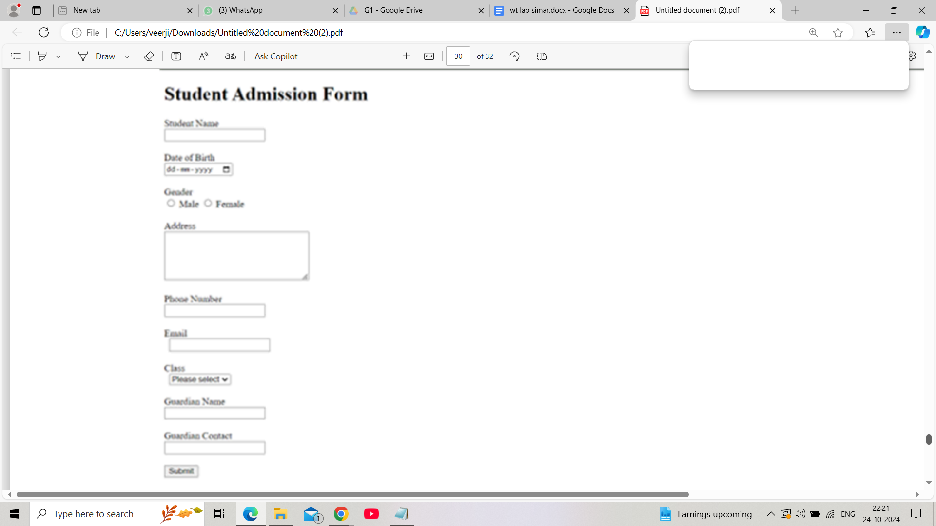

20. Create a proper home page of your own using any components

and styles.

Input:

<!DOCTYPE html>

<html>

<head>

<title>My Personal Website</title>

<link rel="stylesheet" href="styles.css">

</head>

<body>

<header>

<h1>My Name</h1>

<nav>

<ul>

<li><a href="index.html">Home</a></li>

<li><z href =”projects.html”>projects</a></li>

<li>a href =”contact.html”>contact</a><LI>

</ul>

</nav>

</header>

<main>

<section>

<h2>Welcome to My

Website!</h2>

<p>This is a brief introduction about myself. Feel free to explore

my projects and contact .</p>

<img src =”profile_pic.jpg”alt =”profile picture”>

</section>

<main>

<footer>

<p>&copy;2023 my name </p>

</footer>

</body>

</html>

